Portuguese Diploma System, according to:
http://sublimart.blogspot.pt/2012/08/8-diploma-system-portugal.html

Design projects requirements
For the students to receive their diploma they must complete
10 designs representing their experience of a 2 years period.

For the 10 designs they will receive points per project and
they need 80 points to pass, and the maximum they can get
is 100 points.
At least 5 of the projects must have been implemented and
at least 1 must be about networking and social aspects.

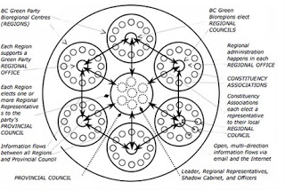

Training requirements
Beside the 10 projects the students must also show their
practical experience and they will also receive points for that.
They need 70 points and the maximum they can get is 100.

The trainning experience is represented by the workshops,
courses, meetings or events that they have been part of, or
developments they have made in permaculture projects.

The portuguese permaculture community will try to provide
specific courses to support the quality of the training for
diploma students.

For minimum 5 days specialization course the students get
10 points per course or per demonstrated working experience.

There are also 10 and 5 points courses according to level of
the learning and working experience.

For the working experience the students can get maximum
100 points and minimum 70 to pass.
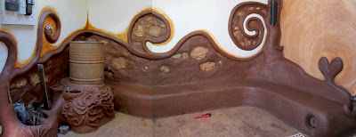
Made on a 5 Days bioconstruction course
Training possibilities

5 days education or practical experience  15 points | Courses and practical experience  10 points | 1-2 day courses, workshops  5 points
Advanced design course  Water resource management  Soils analysis  Productive landscapes  Project management | Forest gardening  Horticulture  Teacher trainning  Bioconstruction  Urban design  I.T.  Community / Networking  Marketing / Fund raising  Appropriate tehcnologies | Mushroom  Aquaponics  Composting  Wormcomposting  Bee keeping  Animal husbandery  Food processing  Reskilling  Basket making  Leather work  Etc

In total the diploma student need to get at least 150 points to be recognized as a diploma holder by the portuguese system.
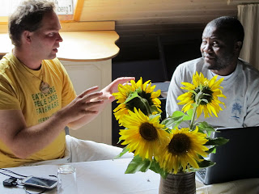
Not many meetings needed
The process
The process starts with a meeting with other people interested and with the coordination of a tutor that will explain the process, this meeting is free of charge and has the function of clarifying and presenting the process to permaculturists.

For the students interested in moving forward the next step of the process is for the student to sent by internet a project or more to the tutor and have a online assessment.

Its important at this stage that the student starts looking for courses or activities were he can get the working experience points and start that process at the same time as the design projects.
This also the moment for the student to start developing and publishing the diploma online so that other permaculturists can learn from the experience and also the tutor can see at any moment the stages of development.
(This is not obligatory, but there is an extreme importance on sharing the achivements with the permaculture community)

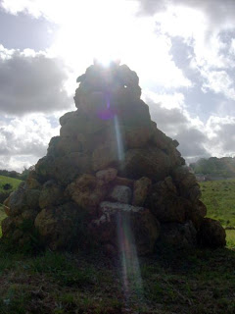

Then there is the first personal meeting were the tutor will have a look at 5 or more projects designed by the students and feedback on what can be improved.

The next step is the second virtual assessment to present 7 or more projects for the tutor to help on adjustment of parts that need deeper development.

We get then to the final assessment with two tutors to adjust the final details of the projects and experience and to prepare the final presentation.

Moment for the final presentation in a opened event for the permaculture community and for the celebration of the achievements.

The total price for this experience is 275 euros that will go to the maintenance of the academy hosting the process and for the tutor input.
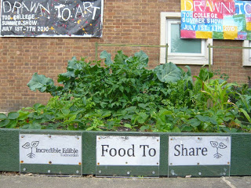
Fair share
Master plan
Moment 1
-Meetings to discuss international examples and develop portuguese process

Moment 2
-Develop effective system that is user friendly and keeps high standards

Moment 3
-Organize presentations and promote on the internet

Moment 4
-Test the tool

Moment 5
-Increase the number of tutors

Zoning

The portuguese diploma is part of the work in zone 00.

